Whitfield Wildlife Conservation Area, Master Naturalist Program
P.O. Box 170
Belen, NM 87002

505.864.8914
eemanagervswcd@gmail.com
www.whitfieldwildlife.org

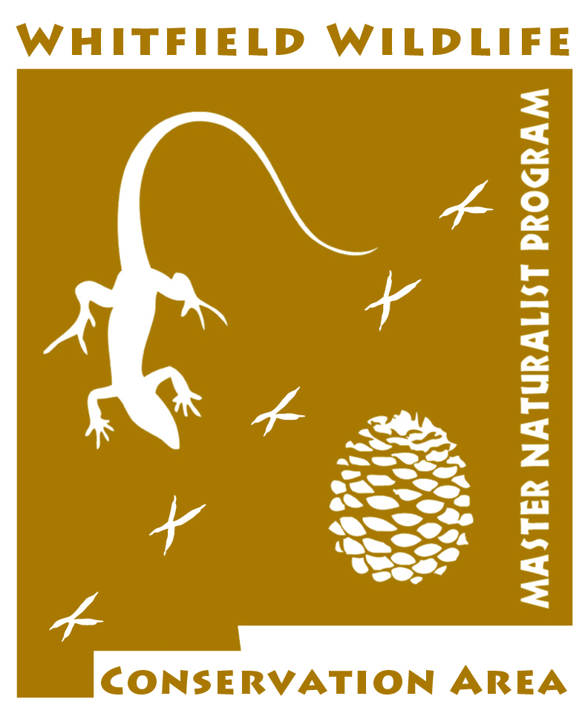
WELCOME TO THE
MASTER NATURALIST PROGRAM!

Master Naturalists are trained volunteers with the Whitfield Wildlife Conservation Area (WWCA). Participants will embark on a fun, active training program. You can:

- experience the wide diversity of open spaces within Valencia County;
- learn about the local environment through such topics as ecology, biomes, geology, water in NM, observations of nature and more;
- share the values and benefits that natural areas add to our lives;
- make connections between species and landscapes;
- understand management affecting natural areas;
- develop skills and acquire training useful in other settings;
- meet others who love nature, too!

The Whitfield Wildlife Conservation Area Master Naturalist Program aims to instill the pursuit of life-long learning and stewardship of the local environment by engaging citizens in providing education and service dedicated to the beneficial management of natural resources on WWCA properties. This program provides an excellent opportunity to participate in conserving, preserving and restoring the local environment. Through the program, a select group of dedicated participants experience a wide range of classes, training, and hands-on experiences. Once the class and field studies have concluded, participants complete a 40 hour service project with the assistance of the VSWCD, the Master Naturalist Advisory Committee, and local partners. Participants are awarded a certificate at the end of their service project identifying them as a Master Naturalist.

2020 Application for the Master Naturalist Program
Volunteer Position with Whitfield Wildlife Conservation Area

Please print or type, except for the signature at the end of the application.

Name:________________________________________________________________________
Address:_________________________________________________Zip__________________
Telephone Number:______________________(home)__________________________(business)
Email: _________________________________________________

How did you hear about the Master Naturalist Program?_________________________________

Please review the training schedule:
2020 Training Schedule:
Participants are urged to attend all classes. If a class is missed, the participant must make it up in a manner approved by the Master Naturalist Advisory Committee. No more than two classes may be missed.

The 2020 training will be held every Wednesday from 5:30pm – 8:30pm starting March 25, April and ending May 20 of 2020 as well as four Saturdays: April 4, April 18, April 25, May 9, May 16th (Make up).

Application deadline: Friday, March 6th. There is a fee of $85.00 payable to the Valencia Soil and Water Conservation District (VSWCD).

Are there any sessions that you are unable to attend?

 no  yes If yes, which ones(s)?________________________________

The training schedule may be subject to changes. Please note that it is extremely important that you attend every class. Each class provides valuable information that is not available elsewhere. If you miss more than two classes, you will be asked to reapply to a subsequent training when you are able to attend.

EMPLOYMENT AND VOLUNTEER HISTORY
Your resume may be substituted for this form if it includes all the information requested.
List most recent experiences first.

Name of Business or Organization:_________________________________________________
Address of Business or Organization:_______________________________________________
_____________________________________________________________________________

Name of Supervisor: _________________________Telephone No. _______________________
Responsibilities: _______________________________________________________________
_____________________________________________________________________________
_____________________________________________________________________________
Worked with them from: ____________________ to: __________________________________
Paid Employment?  yes  no Volunteer Work?  yes  no
Name of Business or Organization:_________________________________________________
Address of Business or Organization:_______________________________________________
_____________________________________________________________________________

Name of Supervisor: _________________________Telephone No. _______________________
Responsibilities: _______________________________________________________________
_____________________________________________________________________________
_____________________________________________________________________________
Worked with them from: ____________________ to: __________________________________
Paid Employment?  yes  no Volunteer Work?  yes  no
Name of Business or Organization:_________________________________________________
Address of Business or Organization:_______________________________________________
_____________________________________________________________________________

Name of Supervisor: _________________________Telephone No. _______________________
Responsibilities: _______________________________________________________________
_____________________________________________________________________________
_____________________________________________________________________________
Worked with them from: ____________________ to: __________________________________
Paid Employment?  yes  no Volunteer Work?  yes  no
Do you have any educational, vocational, or technical training that is relevant to the Master Naturalist Program?
_______________________________________________________________________________________________________________________________________________________________________________________________________________
_____________________________________________________________________________________________________
_____________________________________________________________________________________________________
_____________________________________________________________________________________________________
_____________________________________________________________________________________________________
_____________________________________________________________________________________________________
_____________________________________________________________________________________________________

Additional skills:
_____________________________________________________________________________________________________
_____________________________________________________________________________________________________
_____________________________________________________________________________________________________
_____________________________________________________________________________________________________

Additional Information: __________________________________________________________________________________________________________________________________________________________________________________________________________________
_____________________________________________________________________________________________________
_____________________________________________________________________________________________________
Applicants are considered for volunteer positions for which they have applied without regard to race, religion, sex, age, national origin, disability and other characteristics protected by law. However, applicants do need to be 18 years or older to apply.

I understand that any false answers or misleading statements as well as misrepresentations by omission made by me as part of my application, will be sufficient for rejection of my application or for my immediate discharge should one be discovered after I have started volunteer activities.

I understand that nothing in this volunteer application is intended to create an employment contract between the VSWCD and me. Accordingly, either the VSWCD or I may terminate my volunteer status at-will at any time with or without cause or notice. I understand that I will not be paid or receive any other remuneration for my services as a volunteer with the VSWCD.

I understand that successful completion of a background check is a qualification to volunteer in the Master Naturalist Program.

I hereby acknowledge that I have read, understand, and agree to the preceding statements.

Signature: _________________________________________ Date: ________________________

Please submit your application:

Mail: Education Manager, Whitfield Wildlife Conservation Area, P.O. Box 170, Belen, NM 87002

Email: eemanagervswcd@gmail.com

In Person at the Whitfield Wildlife Conservation Area Visitors’ Center

Application deadline is Friday, March 6th, 2020.

